S_ALR_87013046 -

Functionality
Report that compares a material cost estimate with the preliminary cost estimate for a manufacturing order.

You can use this report to compare a material cost estimate with the planned costs of manufacturing orders for this material.

You can use transaction KOC4 to find orders by material and plant. After execution you can even display plan comparison between two selected orders via Goto -> Detailed analysis.

Scenario
You want to compare cost estimate (planned 0-2) with preliminary cost estimate of process order (planned 0-1).

Requirements
Cost estimate was released and preliminary cost estimate was saved.

Menu Path | Accounting → Product Cost Controlling → Product Cost Planning → Information System → Object Comparisons → For Material → S_ALR_87013046 - Material Cost Estimate vs. Preliminary Order Cost Estimate
Transaction Code | S_ALR_87013046

1. Double click on S_ALR_87013046 - Material Cost Estimate vs. Preliminary Order Cost Estimate.
Planned Costs: Selection

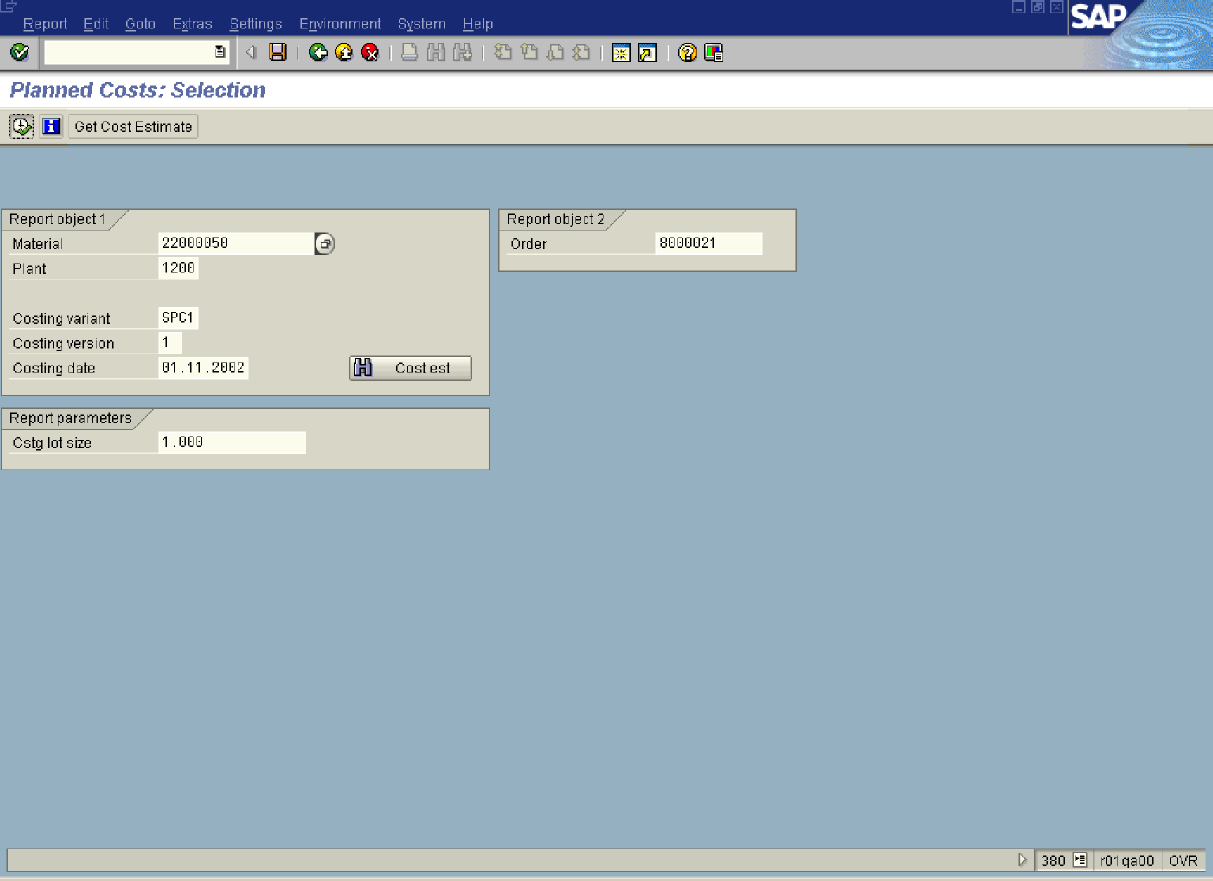

2. Update the following fields:

Field Name | Description | Values
Material | Code identifying a product or component | Example: 22000050
Plant | Code identifying the operational unit of the company where the material is manufactured and stored | Example: 1200
Costing variant | The costing variant used during cost estimate calculation. | Example: SPC1
Costing version | The costing version code. | Example: 1
Costing date | Description of the Costing date. | Example: 16.11.2002
Order | Number identifying the order | Example: 8000021
3. Click the Execute button.

Total values

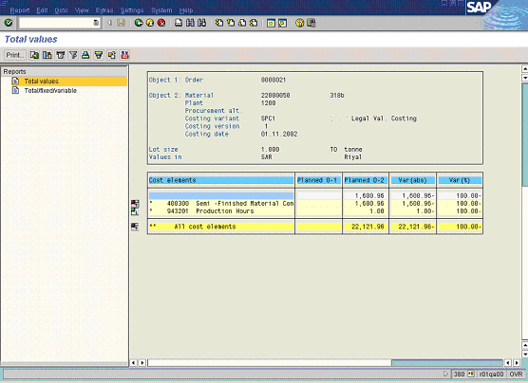

4. Click the Back button.
Planned Costs: Selection

5. Click the Back button to go back to SAP Easy Access screen.

